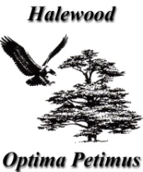

MISSION STATEMENT

Halewood Town Council is committed to improving the quality of life for all who live, work, visit or do business within the Township.

In doing so, the Town Council will:

- Deliver its services to the highest quality in terms of efficiency, effectiveness, and economy in terms of value for money.

- Conduct its business openly and democratically and will consult with the local people.

- Consider good practice from other similar sized Town Councils.

- Examine and challenge through periodic reviews, how a service is delivered.

- Work in partnership with the community and voluntary organisations and with the statutory, public, private sector for the benefit of all residents. The council is committed to working in partnership with other local providers, bringing additional resources into the township, and working in a collaborative and positive way to maintain and increase opportunities for children and young people across the area.

- Maintain its use of open and fair competition when considering tenders and the provision of services acting always within Financial Regulations.

- Comply with the National Code of Local Government Conduct regarding standards in public life.

- Act in the best interests of local people in making appropriate representations to Knowsley Metropolitan Borough Council,
Central Government and other appropriate private and public sector groups.

