HalewoodTownCounciI

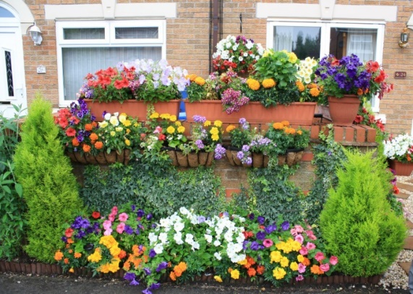
GARDENING COMPETITION 2022
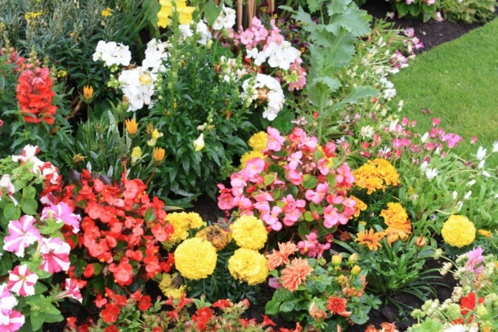
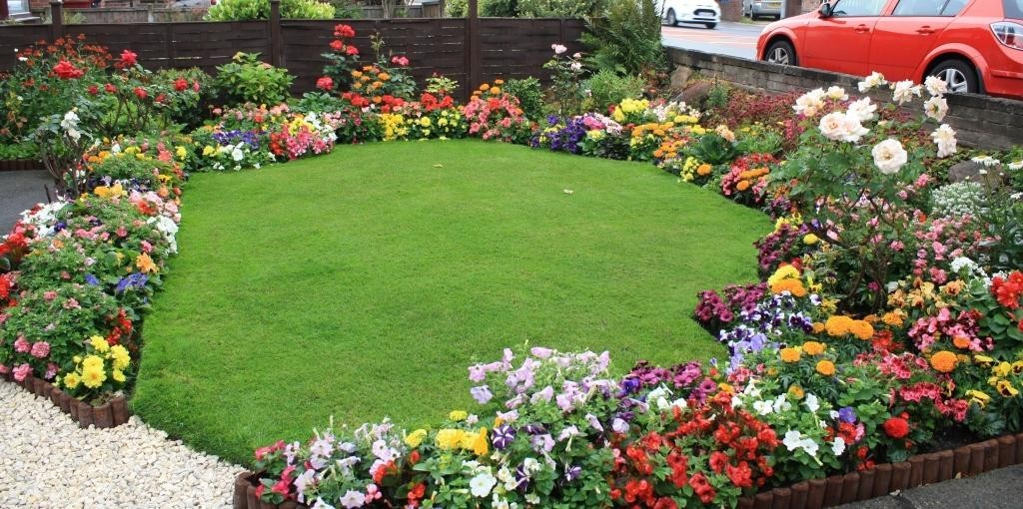

ENTRY FORM
The Town Council is inviting applications from Halewood parish residents for the 2022 Gardening Competition.
All entry forms must be sent to the Town Council at: The Arncliffe Sports and Community Centre Arncliffe Road
Halewood L25 9PA
Or e-mail your entry form to:
Htc-communityprojects@outlook.com

By the CLOSING DATE of Friday 22nd July 2022 (Midday)
Name of Entrant.......................................................

Address of Garden........................................................................Postcode.....................

Contact Telephone Number .................................Email address...................................

Category entered (please tick) | Best Kept Garden | [ | ]
 | Most Colourful Garden | [ | ]
 | Best Hanging Basket | [ | ]

I agree to abide by the rules of the competition set by Halewood Town Council, and acknowledge that the decision of the panel of judges, in each category is final.

Signed by Entrant (self-nomination) ...........................or Friend / Neighbor...........................

Rules of the Competition:

- Only front gardens will be considered for judging, from all types of properties within the Parish boundary.
- Judging will take place in the week commencing Monday 22nd July 22.
- All entrants give their permission for photographs to be used by the Town Council for publicity purposes.
Prizes:
(subject to Town Council approval)

The prize winner in each category will receive £100 and the overall winner will receive the inaugural ‘Norman Hogg Shield’ for 1 Year.

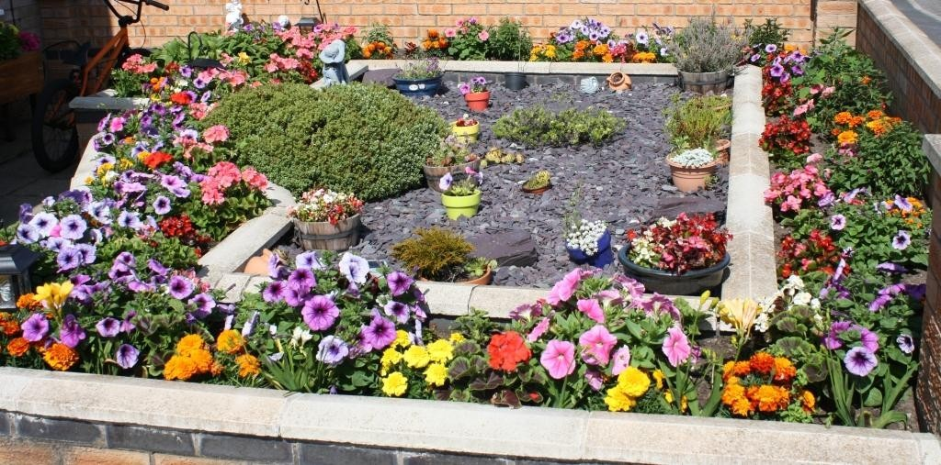
GOOD LUCK!

