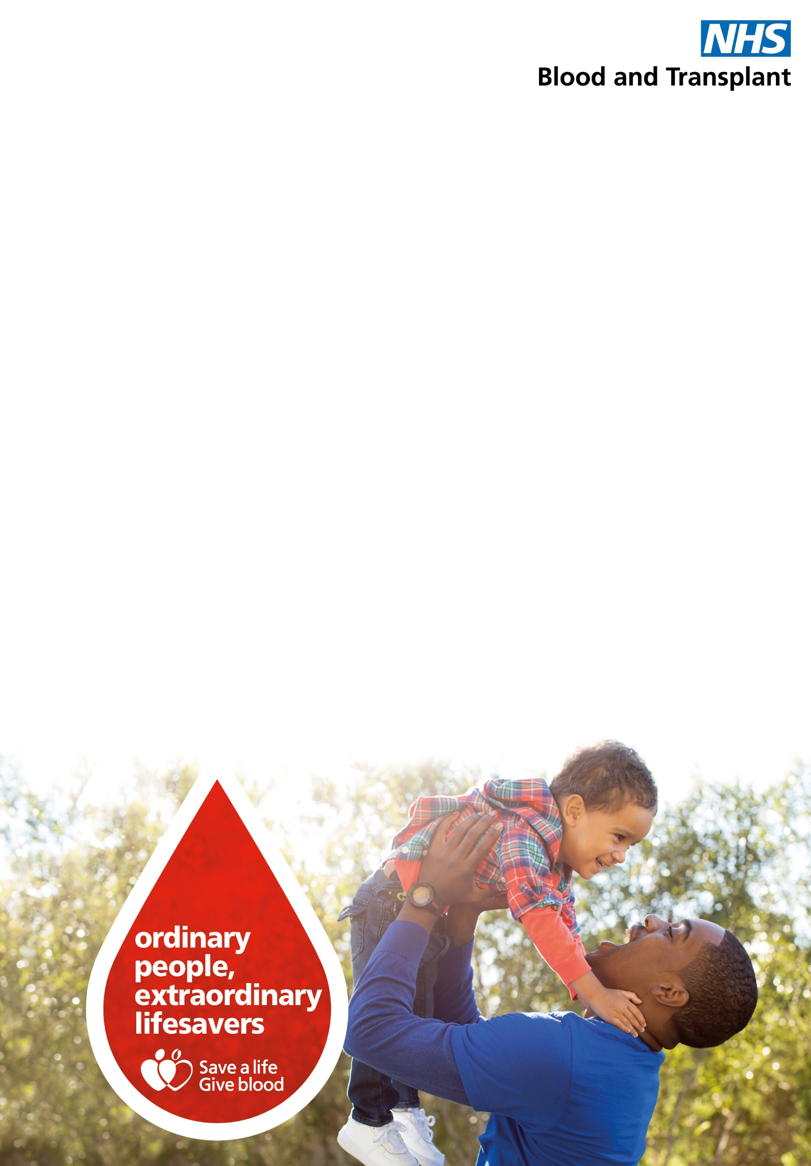

**Your NHS needs you**

**Please help us to supply lifesaving blood to the hospitals during the pandemic by giving blood in your area**

**Crowne Plaza**

The Aerodrome

Speke Road, Speke

Liverpool, L24 8QD

**08/07/2021**

**14.05pm to 19:15pm**

Book an appointment or register to give blood at [**blood.co.uk**](http://www.blood.co.uk) or call **0300 123 23 23**



