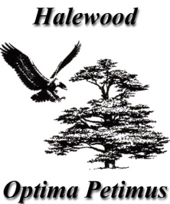
Council of the Year
2017
HALEWOOD TOWN COUNCIL

2018 COMMUNITY ACHIEVEMENT AWARDS

Halewood has many people who ‘go out of their way’ to help others. FACT!

The Town Council's Community Achievement Awards are designed to acknowledge the unsung heroes of our community.

To nominate an individual or group for an award this year, please complete this nomination form and return it to our offices at:

The Arncliffe Sports and Community Centre
Arncliffe Road
Halewood L25 9PA

or email it to admin@halewoodtowncouncil.gov.uk

by FRIDAY 16th MARCH 2018

The Award Ceremony will take place at Hollies Hall on 27th April 2018.
…………………………………………………………………………..

Name of Person or Group to be nominated..............................................................................
Their Full Address……………………………………………………………………………………………………………………………………………………………………………………………………………………………………………………………………………………………………………....................
Why are you nominating this Person or Group?
……………………………………………………………………………………………………………
……………………………………………………………………………………………………………
……………………………………………………………………………………………………………
……………………………………………………………………………………………………………
……………………………………………………………………………………......................................................................................................................................................................................
...................................................................................................................................................
…………………………………………………………………………………….......................................................................................................................................................................................
.....................................................................................................................................................

Your Name & Contact Details (inc Telephone Number) …………………………………………………………………………………………….................................................................................................................................................................................................................................................................................................................................

