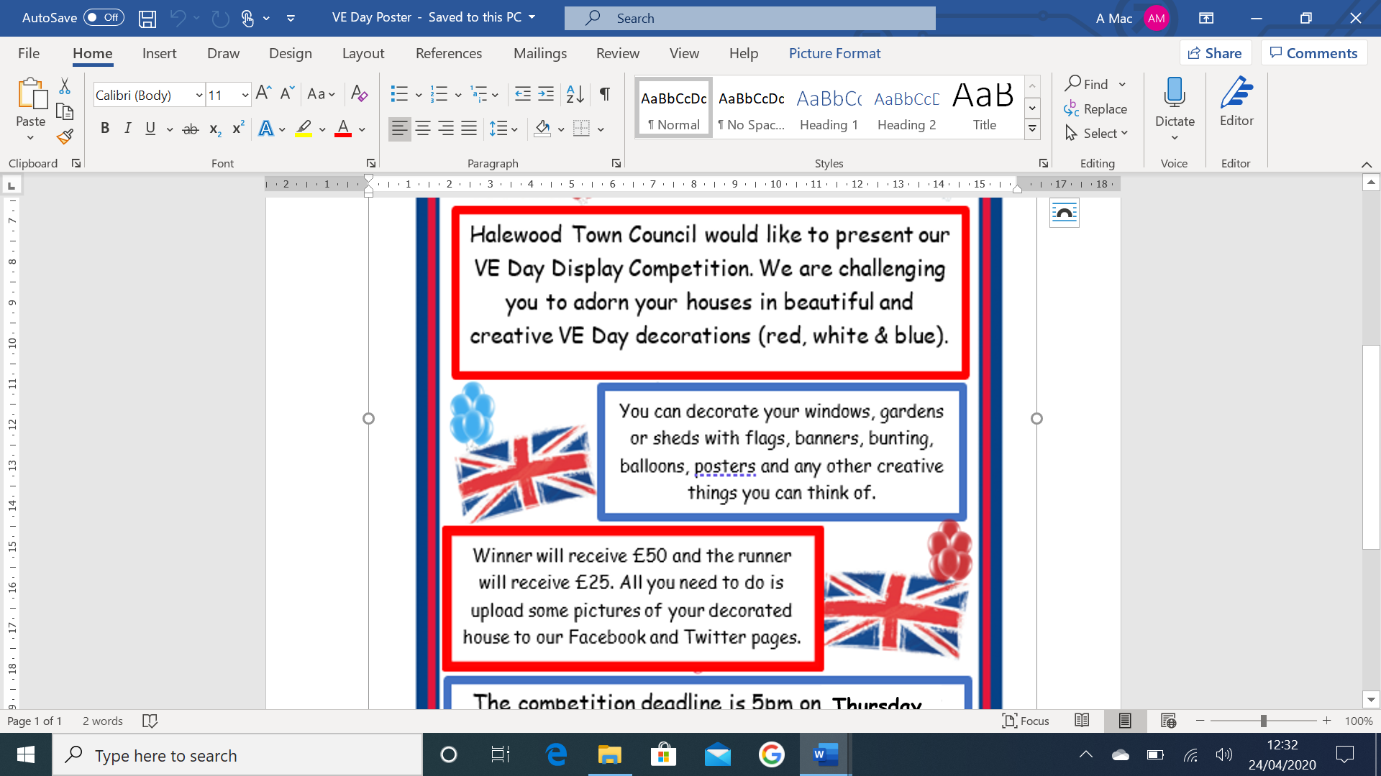

**Halewood Town Council’s**

**VE Day Commemoration Project**

Our Special Edition VE Day 75th Anniversary Newsletter can be found in the link on homepage (to the right of the screen). It is our way of paying tribute to the entire WWII generation for their services that contributed to ‘Victory In Europe’. As we face our most challenging times since WWII, it is important that we can unite in recognition, just as communities did 75 years ago. We would like to thank everybody who contributed to the newsletter, with their amazing stories, photographs and fantastic pictures from some very enthusiastic children. We thoroughly enjoyed sharing your stories and we know that so many people enjoyed reading them too. Feel free to continue the commemoration by joining us in an ‘Afternoon Tea’ from the comfort of your own home.

