Halewood CultureFest
Open Gardens
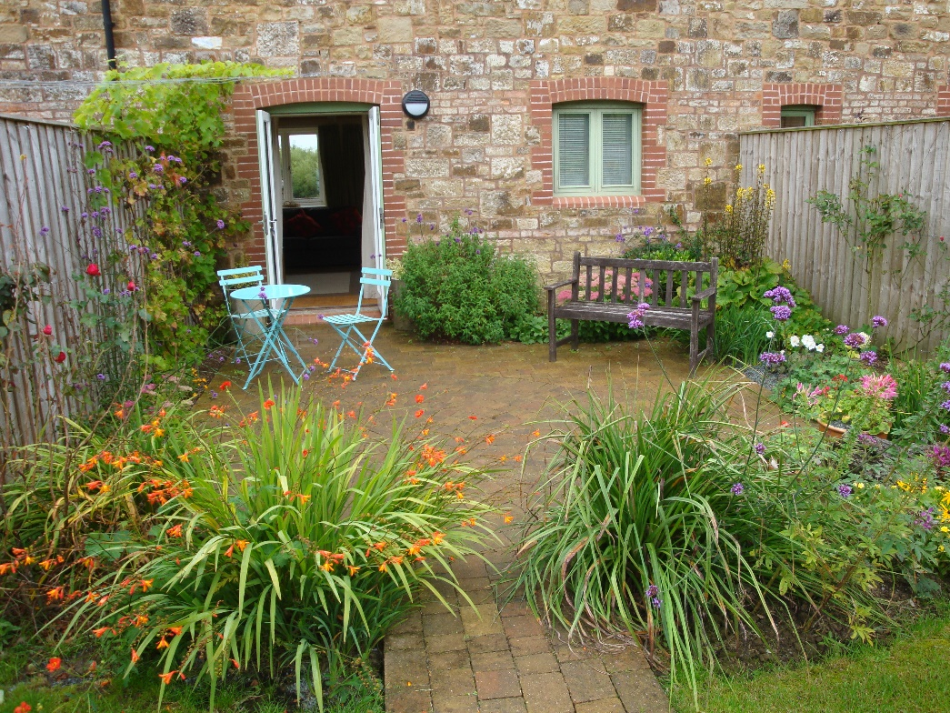
Sunday 24 June 2018
1.00-5.00pm
at various locations around Halewood and surrounding areas

Guided Tours of St Nicholas’ Halewood Churchyard at 2pm and 3pm

Admission free

A Map showing locations of the gardens is attached. They are also available from the Arncliffe Centre, local churches and members of the CultureFest Steering Group

