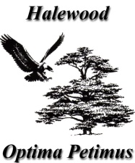
ACTION PLAN 2015-16
- Recognising its status as a Quality Council, consider an application for accreditation under the Local Council Award Scheme.

- Provide ongoing support in the delivery of the Halewood Culturefest.

- Continue to provide representation in various outside bodies, significantly the Halewood Local Advisory Group of the Principal Authority.

- Maintain practical support to the community if Halewood through its Community Grants Fund.

- Fund three seasonal pantomimes throughout the Township, at New Hutte Neighbourhood Centre, Hollies Hall and the Arncliffe Centre.

- Provide support for the older members of our community through the weekly Luncheon Club and Christmas Party.

- Develop and gain Town Council approval for a development plan for our leasehold/freehold green spaces and woodland.

- Undertake a major role in the development and delivery of a Christmas Concert at Halewood Academy involving members of the Royal Liverpool Philharmonic Orchestra (RLPO) and all schools within the Township.

- Finalise and implement the review of Town Council staffing.

- Administer all meetings of the Town council, preparing and distributing all required paperwork within prescribed timescales.

- Prepare, publish and distribute the Annual Report.

- Continue the review of Town Council Policies and the maintenance and updating of the Town Council website.

- Consider, as funds allow, the further development of Town Council facilities.

- Continue to provide support to children, young people and families in most need of help.

- Recognise the significant contribution to Halewood of the young people in our schools and the achievement of others within our community.

